

UNIVERSITY OF WAIKATO SUMMER RESEARCH SCHOLARSHIP

FINAL REPORT TO RESEARCH COMMITTEE

(Max 2 pages in length)

PROJECT TITLE: | Performing distributed experiments using Hadoop
STUDENT: | Zufeng Yu
SUPERVISOR: | Geoff Holmes, Peter Reutemann
DEPARTMENT: | Computer Science
START DATE OF PROJECT: | 14 Nov 2011
COMPLETION DATE OF PROJECT: | 14 Feb 2012
DATE OF REPORT: | 14 Feb 2012

Project achievement:

Reducing the time it takes for experiments of the machine learning workbench WEKA to execute is a crucial step towards large-scale experiments. Our project aims at integrating the Apache Hadoop map/reduce framework into the machine learning and data mining framework ADAMS, which encompasses the WEKA software and is currently developed here at the University of Waikato in the Machine Learning group.

WEKA only offers limited support for distributed experiments, via the remote experiment mechanism, with most researchers only running experiments on their local workstation. The map/reduce paradigm offers a compelling approach to performing distributed experiments, as there are usually multiple classifiers being evaluated on multiple datasets.

Apache Hadoop is open-source software for reliable, scalable and distributed computing. The Apache Hadoop software library allows for the distributed processing of large datasets across clusters of computers using a simple programming model. It is designed to scale up from single servers to thousands of machines, each offering local computation and storage. Rather than relying on hardware to deliver high-availability, the library itself is designed to detect and handle failures at the application layer, so delivering a highly-available service on top of a cluster of computers, each of which may be prone to failures.

Research results:

In the course of the project, we developed a standalone application for experiments, which can be run from command-line. In addition, we implemented a graphical user interface, called Hadoop Experimenter, as part of the ADAMS suite, for a more convenient way of launching distributed experiments. It resembles the original WEKA Experimenter and the experiment set ups are interchangeable between the two applications, as long as cross-validation is used as experiment type. However, the Hadoop Experimenter has some additional options that define how the experiments are run on either the local machine or on a Hadoop cluster.

We designed some experiments to show the performance differences between the WEKA Experimenter and the Hadoop Experimenter. The experiment set up uses 1, 3 and 5 UCI datasets and the classifiers J48 (WEKA's C4.5 implementation), RandomForest, SMO (linear support vector machine). Default options were used for all classifiers. We compared the run time of the WEKA Experimenter versus the Hadoop Experimenter with a varying number of cluster nodes: 1, 5, 10 and 20. The results are shown in Figure 1.

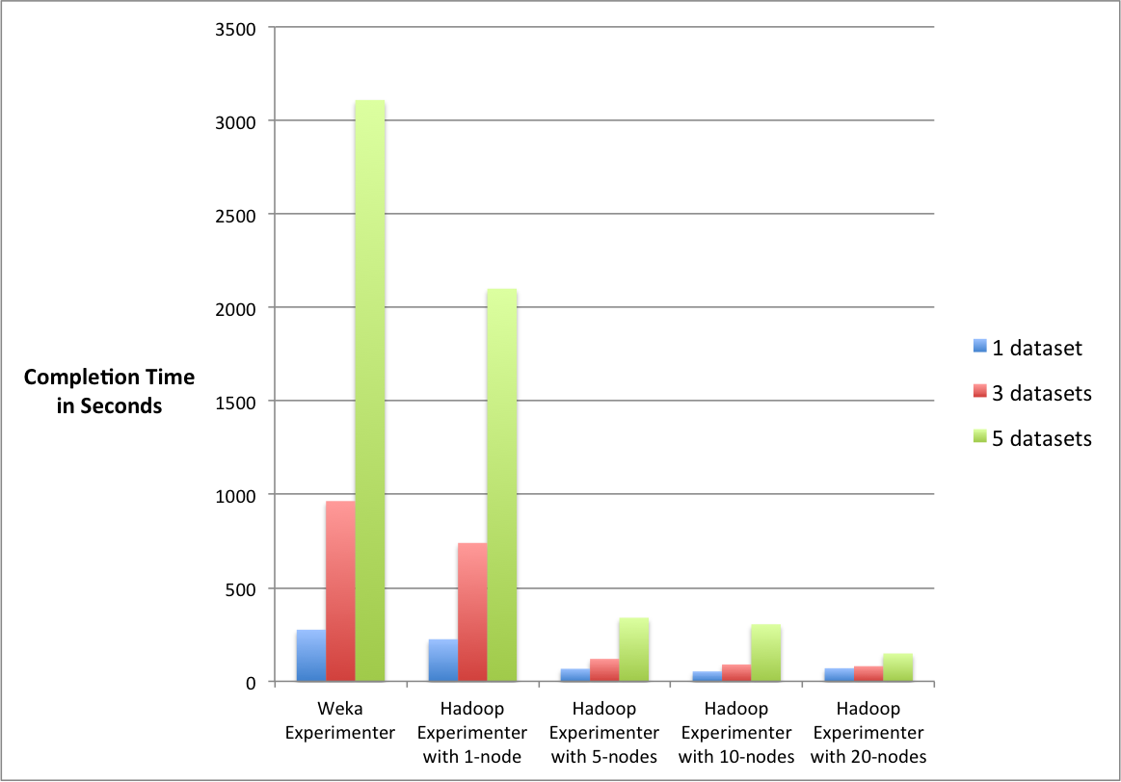Figure 1: Run time comparison between WEKA and Hadoop Experimenter

We can see that for the 1 dataset experiment (blue bars), the WEKA Experimenter and Hadoop Experimenter with 1 node (using 2 cores on the machine) took about the same amount of time to finish. However, with more nodes available in the cluster, the run time decreased from around 270s to 60s, about 300% (3 times) speed increase. Also note, that the 1 dataset experiments, when executed using 10 nodes and 20 nodes, did not have much difference in speed. This is most likely due to the overhead involved, when Hadoop initializes the execution of a task. In this case the experiment was too small to see any significant performance differences.

For the 3 datasets experiment (red bars), the differences in run time between the two experimenters are obvious, with 16min for the WEKA Experimenter, 2min using 5 nodes, 1min 30s using 10 nodes, and 1min 21s using 20 nodes. On average, this is a speed increase of at least 1000% (10 times).

Looking at the the 5 datasets experiment (green bars), we can see that the WEKA Experimenter used more than 50min, in contrast to the Hadoop Experimenter which only took 2min 29s using 20 nodes. This is the equivalent of a 2500% (25 times) speed increase.

The conclusion that we can draw from these experiments is that the Hadoop Experimenter will perform the better the more cluster nodes are available, compared with the WEKA Experimenter.

In order to have a more detailed view on how much faster the Hadoop Experimenter runs with varying number of cluster nodes, we designed an additional experiment using 10 UCI datasets. This scenario uses the same classifiers, for both, the 10 and 20 cluster nodes set up. The resulting graph is shown in Figure 2.

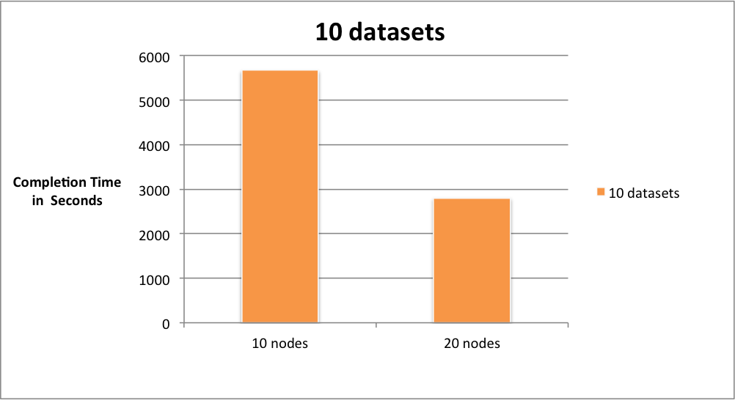Figure 2: Run time comparison with varying number of nodes

Figure 2 clearly shows that the Hadoop set up with 20 nodes cluster runs significantly faster than those with 10 nodes, an approximate 100% speed increase with twice the number of nodes.

To conclude, the performance of the Hadoop Experimenter relies heavily on the input dataset sizes, number and type of classifiers, as the building of a machine learning model still takes up most of the time. But by parallelizing experiments as much as possible, adding more nodes to a Hadoop cluster results in large speed increases for WEKA experiments using the Hadoop Experimenter.

Signed: ………………………………….  (Student)  Date: …………………………... | Signed: ……………………………………………  (Supervisor)  Date: …………………………...

datasets used: waveform-5000 (1,3,5), pendigits (3,5), mushroom (3,5), letter (5), optdigits (5)
Node hardware: Intel Core i7-2600 quad-core 3.40GHz with 16GB of RAM
Additional datasets compared to 5 datasets experiment: arrythmia, spambase, covtype-5000, covtype-50000, spetrometer

